**Litware – Strategy and Plan**

**Microsoft Cloud Adoption Plan**

31st February 2022

**Executive Summary**

Since 1917, Litware has helped to improve the health and safety in the workplace by building a sustainable no-fault insurance system that supports both workers and employers now and for generations to come.

Litware was established by provincial legislation as an agency with the mandate to oversee a no-fault insurance system for the workplace. Litware partners with employers and workers in the US to do the following:

* Promote the prevention of workplace injury, illness, and disease
* Rehabilitate those who are injured, and provide timely return to work
* Provide fair compensation to replace workers' loss of wages while recovering from injuries
* Ensure sound financial management for a viable workers' compensation system

Litware’s goals are as follows.

* Foster the improvement of occupational health and safety in workplaces and communities
* Improve service to stakeholders by:
  + Improving return-to-work outcomes, disability prevention, overall customer service, accessibility, and public confidence
  + Improving adjudicative decision-making throughout the organization, ensuring stakeholders receive their full legal entitlements
* Maintain the cost-effectiveness and accountability of the services we deliver
* Maintain financial security, sustainability, and stability

Litware started their cloud journey in 2019 moving to Office365 and are well underway on their Cloud migration journey as shown below in Figure 1.

*Figure 1: Full Cloud Roadmap*

Figure

: Full Cloud Roadmap

Litware’s focus will be to exit their Datacenter by end of 2022 through an initial phase of rehosting all their solutions in Azure, at which point they will embark on a modernization journey for their applications. Where possible, Litware will want to procure SaaS offerings that meet their business requirements.

**Define Strategy**

Motivations and drivers

Why do you want to adopt the cloud? Are there critical business events driving your decision? Do you have specific business [motivations](https://docs.microsoft.com/azure/architecture/cloud-adoption/business-strategy/motivations-why-are-we-moving-to-the-cloud)?

|  |
| --- |
| Litware currently has an outsourced datacenter contract which expires in March 2024. The datacenter is in the US and houses the 798 servers in Production and Dev/Test for the organization. Litware understands and has adopted a cloud first strategy and wishes to exit the Datacenter (DC) by the end of CY 2023.  Litware is focused on a number of strategies related to their cloud migration, namely:   * Workload Migration * Internet/Intranet application re-hosting * Application Modernization * Application refactoring   A wildfireexperienced significant growth over a 24 hour period in on 18th Aug 2021, burning an area of 62,524 hectares and coming within 30kms of the Datacenter (DC) circled in blue shown in Figure 3 below.  Map  Description automatically generated  Figure : Sample Wildfire map with DC circled in blue |

Business outcomes

What are the expected [business outcomes](https://docs.microsoft.com/azure/architecture/cloud-adoption/business-strategy/business-outcomes/) from adopting the cloud? Collect them in the corresponding table below, organized by priority.

*High Priority*

|  |  |  |  |  |  |  |
| --- | --- | --- | --- | --- | --- | --- |
| Stakeholder: |  | |  | Outcome: | Datacenter evacuation and infrastructure modernization | |
|  |  |  |  |  |  |  |
| Business Drivers | | |  | KPI |  | Capabilities |
| Datacenter Contract expiry | | |  | DC evacuation to cloud for 100% of workloads |  | Cloud first strategy  Modernize infrastructure and allow for digital transformation. |

*Mid Priority*

|  |  |  |  |  |  |  |
| --- | --- | --- | --- | --- | --- | --- |
| Stakeholder: |  | |  | Outcome: | Infrastructure migration to Azure | |
|  |  |  |  |  |  |  |
| Business Drivers | | |  | KPI |  | Capabilities |
| List any business drivers | | |  | List success metrics |  | Enterprise Landing Zone  Infrastructure automation |

*Low Priority*

|  |  |  |  |  |  |  |
| --- | --- | --- | --- | --- | --- | --- |
| Stakeholder: |  | |  | Outcome: | Dynamics 365 & Power Platform | |
|  |  |  |  |  |  |  |
| Business Drivers | | |  | KPI |  | Capabilities |
| Replace K2.net with Power Platform  Replace Business Objects | | |  | List success metrics |  | Reporting modernization  Integrated workflow into Office365 |

Business justification

How would you measure success? Beyond achieving the business outcomes, are there other indicators for successful Azure adoption in your organization?

Consider creating a business case for adopting Azure and create a [financial model](https://docs.microsoft.com/azure/architecture/cloud-adoption/business-strategy/financial-models) to support this plan.

|  |  |
| --- | --- |
| **Business Case - Summary Statistics** | |
| Total Benefits | $ 3,624,645 |
| Total Sum invested | $ 394,000 |
| NPV of Benefits | $ 3,058,298 |
| Internal Rate of Return | 493% |
| Discounted Payback Period in Months | 3 |
| **Average On-Premise TCO** | **$ 2,707,255** |
| **Average Azure TCO** | **$ 1,769,018** |
| **Average Annual Benefit** | **$ 938,237** |
|  |  |

Litware with assistance from Microsoft and their Partner Account team developed a Business Value Assessment **over 6 years** to capture the current IT spend in the Datacenter (DC) and provide a comparison of the migrated workloads into Azure.

From the summary statistics above the Internal Rate of Return (IRR) would be **493%** with a discounted payback period of 3 months and an average annual benefit of **$938,237**. This could realize a total savings of approximately **$5,629,424** over a 6-year period.

The costs associated with running the workloads in Azure show benefits in the area of hardware, maintenance, datacenter, networking, and storage costs. Software costs increase as a result of the highly virtualized environment being migrated which has been licensed with Windows Server Datacenter cores. Although the Azure Hybrid Use benefit will be leveraged, the cost of software is still anticipated to be a marginally higher than on-premise.



Figure : Current state vs Future state



Figure : Annual Savings

First adoption project

The first adoption project should align with the [motivations](https://docs.microsoft.com/azure/architecture/cloud-adoption/business-strategy/motivations-why-are-we-moving-to-the-cloud) behind cloud adoption. Whenever possible, the first project should also demonstrate progress towards a defined [business outcome](https://docs.microsoft.com/azure/architecture/cloud-adoption/business-strategy/business-outcomes/how-to-use-the-business-outcome-template).

Log your first adoption project in here:

|  |  |  |  |  |
| --- | --- | --- | --- | --- |
| Project: | CMS Training Migration |  | Outcome: | Migrate Claims Management System to Azure |
| Stakeholder: |  |  | Business Unit: | Claims training department |

Key stakeholders

Who are the individuals within your organization whose participation is critical for the success of this adoption plan? Collect all key individuals in here, and mark who should be part of the Cloud Strategy Team in the table below. The **Cloud Strategy Team** is responsible for leading the cloud adoption within your organization, supporting all business outcomes, people and processes changes and technical projects identified within this plan.

|  |  |  |  |
| --- | --- | --- | --- |
| Name | Business Unit/Role | Business Outcome Owner (Y/N) | Cloud Strategy Team (Y/N) |
|  | CIO | Y | Y |
|  | Exec Director | Y | Y |
|  | Exec Director | Y | Y |
|  | Program Manager | N | Y |
|  | Technical Specialist | N | Y |
|  | Architect/ Technical Specialist | N | Y |
|  | Chief Security Officer | Y | Y |

Litware are working with Partner ABC through the Azure Migration & Modernization Program (AMMP) to plan and migrate workloads to Azure.

**Plan**

Digital estate

How would you [evaluate current](https://docs.microsoft.com/azure/architecture/cloud-adoption/digital-estate/approach) technology assets as you prepare for cloud adoption?

Start with [gathering this information](https://docs.microsoft.com/azure/architecture/cloud-adoption/digital-estate/inventory) across the organization, and aggregating it in the following tables. At the same time, consider what is the [best approach](https://docs.microsoft.com/azure/architecture/cloud-adoption/digital-estate/rationalize) to move or modernize these to the cloud, considering the [5 Rs of rationalization](https://docs.microsoft.com/azure/architecture/cloud-adoption/digital-estate/5-rs-of-rationalization). Always consider take an ‘incremental’ approach in this journey, meaning don’t try to list all your targets in your first attempt but grow them over time as you revisit this plan.

*Migration targets:*  *leverage* [*migration examples*](https://docs.microsoft.com/en-us/azure/architecture/cloud-adoption/migrate/azure-best-practices/contoso-migration-assessment) *that can help you create a centralized list of all VMs and servers.*

|  |  |  |  |
| --- | --- | --- | --- |
| Application/Workload | Business Unit | Business Priority (high, mid, low) | Proposed Rationalization |
| Assessments A/R 9.2 | Assessments | High | Rehost |
| Employer Account System (EAS) | Assessments | High | Rehost |
| Maximizer | Assessments | High | Rehost |
| API’s (37)  Messaging Interfaces | Assessments | High | Rehost |
| Claims Management training environment | Claims/Healthcare | High | Rehost |
| Provider Portal | Claims/Healthcare | High | Rehost |
| Batch Applications & API’s (15)   * Batch Applications * Windows Service Apps * API’s | Claims/Healthcare | High | Rehost |
| WebForm   * Front End tier * Application tier * Database tier | Reviews & Appeals | High | Rehost |
| Batch application & API’s   * Batch Applications * Windows Services Apps * API’s | Reviews & Appeals | High | Rehost |
| HRSoft | Finance/HR | High | Rehost |
| Batch application & API’s   * Batch Applications * API’s | Finance/HR | High | Rehost |
| PrevInv App | Prevention & Investigations | High | Rehost |
| PrevInv Portal | Prevention & Investigations | High | Rehost |
| API’s | IT (Infrastructure) | High | Rehost |
| Bus | Corporate Services | Medium | Rehost |
| Sender | Corporate Services | Medium | Rehost |
| Data Warehouse | Analytics & Reporting | High | Rehost |
| Reporting | Analytics & Reporting | High | Rehost |
| Library | IT Applications | Low | Rehost |
| Media | IT Applications | Low | Rehost |
| Quality Center | IT Applications | Low | Rehost |
| Tableau | IT Applications | Low | Rehost |
| Carousel | IT Applications | Low | Rehost |
| Security Components   * Define Components here | IT Infrastructure | High | Rehost |
| Unified Communications Components   * Define Components here | IT Infrastructure | High | Rehost |

*Innovation targets: opportunities to improve your customer experience, opportunities to innovate.*

|  |  |  |  |
| --- | --- | --- | --- |
| Application/Workload | Business Unit | Business Priority (high, mid, low) | Proposed Rationalization |
| Data Warehouse | Analytics & Reporting | High | New |
| Claims Management | Claims/Healthcare | High | Refactor |
| K2 | IT Applications | High | Replace |

Organizational alignment

How to ensure your [organization is aligned](https://docs.microsoft.com/azure/architecture/cloud-adoption/plan/initial-org-alignment) and ready for Azure adoption? It’s critical to align people to capabilities needed to adopt Azure. Complete the following table with the people in the organization, mapping to specific capabilities:

|  |  |
| --- | --- |
| Name of people responsible for… | |
| Delivering technical tasks | Implementing cloud governance |
|  |  |
|  |  |

These people will work aligned with the Cloud Strategy Team identified earlier in the Strategy phase.

Skills readiness plans

Litware currently have a cloud team established and committed to assessment, planning & migration of workloads to Azure.

For successful cloud adoption, it’s critical to ensure your people, IT and non-IT, are [ready](https://docs.microsoft.com/azure/architecture/cloud-adoption/plan/adapt-roles-skills-processes) for this transformation. Including in the table below, the key courses your organization needs to take for this process.

|  |  |  |  |  |
| --- | --- | --- | --- | --- |
| Course name | Audience (Cloud Architect, IT, Admin, Ops) | Level  (100, 200, 300, 400) | Source  (MS Learn, Pluralsight, ESI) | Priority  (high, mid, low) |
| [Microsoft Cloud Adoption Framework for Azure](https://docs.microsoft.com/en-us/learn/modules/microsoft-cloud-adoption-framework-for-azure/index) | Admin, Devs, Cloud Architect, Business User, Cloud Engineer | 100 | MS Learn | High |
| [Azure Fundamentals](https://docs.microsoft.com/en-us/learn/paths/azure-fundamentals/) | Admin, Devs, Cloud Architect, Business User, Cloud Engineer | 100 | MS Learn | High |
| [Learn the Business Value of Azure](https://docs.microsoft.com/en-us/learn/paths/learn-business-value-of-azure/) | Business User | 100 | MS Learn | Mid |
|  |  |  |  |  |
|  |  |  |  |  |
|  |  |  |  |  |
|  |  |  |  |  |

[Suggested](https://docs.microsoft.com/azure/architecture/cloud-adoption/plan/suggested-skills) skills are included in here, and more information on available, free, on-demand Azure technical readiness at [MS Learn](https://docs.microsoft.com/en-us/learn/).

Cloud Adoption Plan

Cloud adoption plans convert the aspirational goals of the cloud adoption strategy into an actionable plan. The collective cloud teams can leverage the cloud adoption plan to guide technical efforts, in alignment with the business outcomes.

Your organization’s cloud adoption plan is here. You have identified the business drivers for this transformation. You have a financial understanding of the impact of this decision. You have completed an initial analysis to your current workloads, assets and applications to identify their path to the cloud. Your people is ready or aligned to a plan to get ready.

Now, let’s get ready for starting the initial implication conversations within your organization. Consider leveraging [Azure DevOps](https://docs.microsoft.com/azure/architecture/cloud-adoption/plan/template) to log and track your projects for cloud adoption and create a [timeline](https://docs.microsoft.com/azure/architecture/cloud-adoption/plan/timelines) for these projects, and others to come, to materialized.

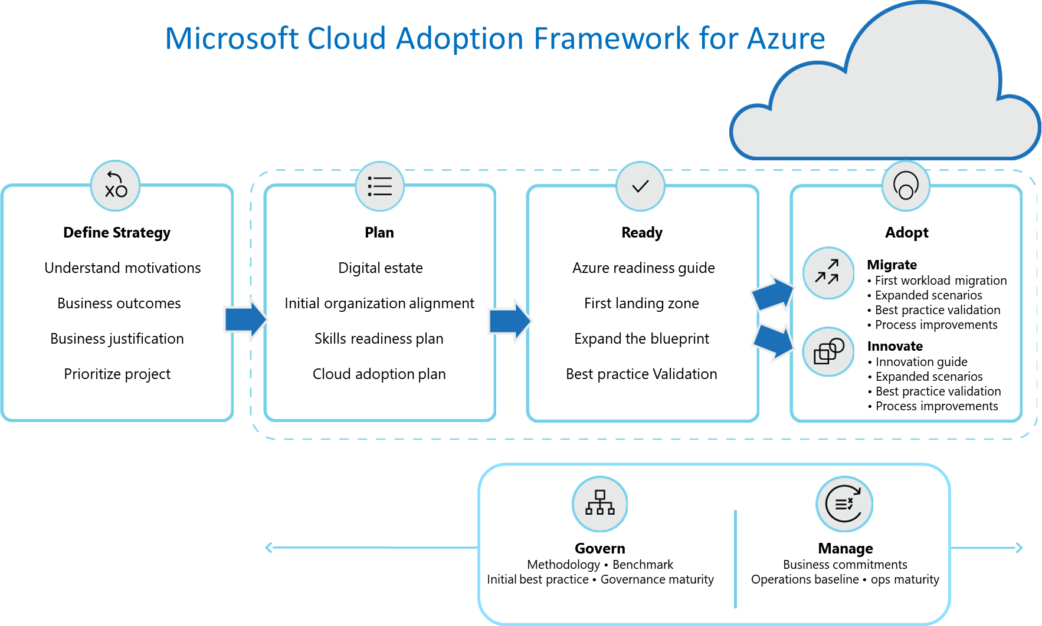

<https://aka.ms/cloudadoptionframework>